**DAILY ONLINE ACTIVITIES SUMMARY**

|  |  |  |  |  |  |  |  |  |
| --- | --- | --- | --- | --- | --- | --- | --- | --- |
| **Date:** | **18/05/2020** | | | | | **Name:** | **Ravi k r** | |
| **Sem & Sec** | **8B** | | | | | **USN:** | **4AL16CS076** | |
| **Online Test Summary** | | | | | | | | |
| **Subject** | | **SMS** | | | | | | |
| **Max. Marks** | | **60** | | **Score** | | | **44** | |
| **Certification Course Summary(Internship)** | | | | | | | | |
| **Task** | **Spring Framework Getting Started And Dependency Injection Fundamentals Tutorial For Real World Application Development** | | | | | | | |
| **platform** | | | **Udemy** | | **Duration** | | | **2 hr** |
| **Coding Challenges** | | | | | | | | |
| **Problem Statement:1)**Using methods charAt() & length() of String class, write a program to print the frequency of each character in a string.  2)Write down a java program to print even and odd numbers series respectively from two threads: | | | | | | | | |
| **Status:completed** | | | | | | | | |
| **Uploaded the report in Github** | | | | | **Yes** | | | |
| **If yes Repository name** | | | | | <https://github.com/Ravikr973161/certification-Programming> | | | |
| **Uploaded the report in slack** | | | | | **Yes** | | | |

ONLINE TEST:

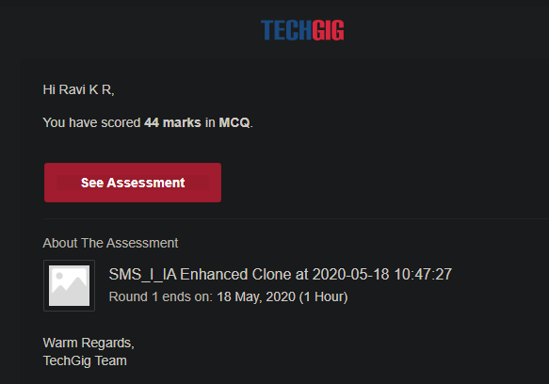

Certification:

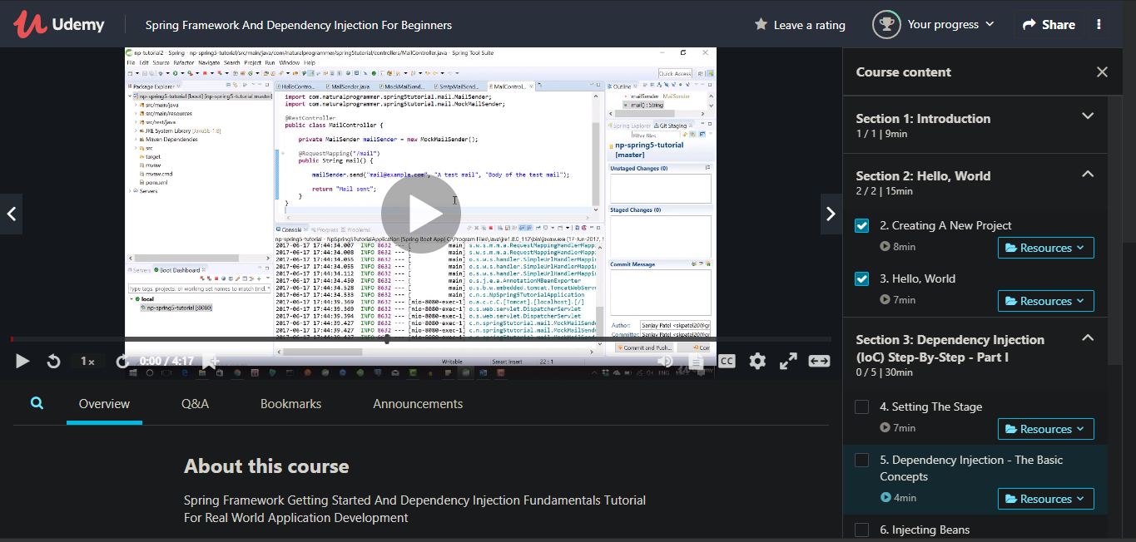

CODING CHALLENGE:

PROGRAM 1 :

package pk;  
import java.util.Scanner;  
public class StringOperators  
{  
public static void main(String args[])  
{  
int i;  
String str;

int counter[] = new int[256];

Scanner in = new Scanner(System.in);

System.out.print("Enter a String : ");

str=in.nextLine();

for (i = 0; i < str.length(); i++) {

counter[(int) str.charAt(i)]++;

}

for (i = 0; i < 256; i++) {

if (counter[i] != 0) {

System.out.println((char) i + ":-" + counter[i] + " times");

}

}

}  
}

PROGRAM2:

public class PingPong extends Thread {  
static StringBuilder object = new StringBuilder("");

public static void main(String[] args) throws InterruptedException {

Thread t1 = new PingPong();  
Thread t2 = new PingPong();

t1.setName("\nping");  
t2.setName(" pong");

t1.start();  
t2.start();  
}

[@override](https://github.com/override#trash/_blank)  
public void run() {  
working();  
}

void working() {  
while (true) {  
synchronized (object) {  
try {  
System.out.print(Thread.currentThread().getName());  
object.notify();  
object.wait();  
} catch (InterruptedException e) {  
e.printStackTrace();  
}  
}  
}  
}  
}